**Restaurant Order Analysis in SQL**

Tables: menu_items and order_details

|  |  |
| --- | --- |
| Fields | Description |
| menu_item_id | Unique ID of a menu item |
| item_name | Name of a menu item |
| category | Category or type of cuisine of the menu item |
| price | Price of the menu item (US Dollars $) |

Menu_items:

|  |  |
| --- | --- |
| Fields | Description |
| order_details_id | Unique ID of an item in an order |
| order_id | ID of an order |
| order_date | Date an order was put in (MM/DD/YY) |
| order_time | Time an order was put in (HH:MM:SS AM/PM) |
| item_id | Matches the menu_item_id in the menu_items table |

Order_details:

Analysis:

Menu Items In The Table:

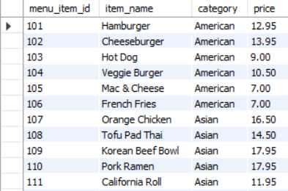

Number Of Items In The Table:



Least And Most Expensive Items In The Table:





Count Italian Dishes On The Menu:



Least And Most Expensive Italian Dishes On The Menu:





Count Dishes In Each Category:

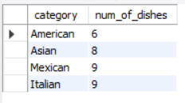

Find Average Dish Price Within Each Category:

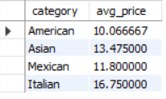

Order Details Table:

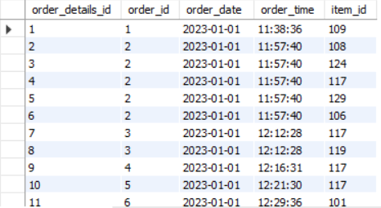

The Date Range Of The Table:



Number Of Orders Made Within This Date Range:

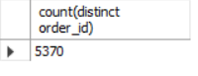

Number Of Items Ordered Within This Date Range:



Orders With Most Number Of Items:

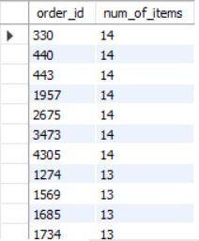

Orders With More Than 12 Items:



Combine Menu_Items And Order_Details Table Into A Single Table:

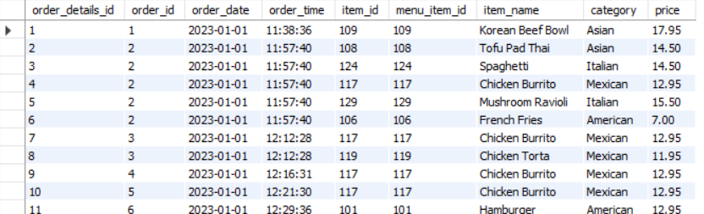

What Were The Least And Most Ordered Items And What Category Were They In:





What Were The Top 5 Orders That Spent The Most Money;

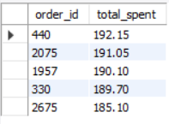

Details Of The Highest Spent Order;

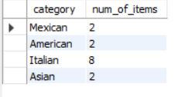

Details Of Top5 Highest Spent Orders;

